Draftwork Student Guide
How to write an assignment in Draftwork, save your files and upload them to your course
Draftwork 0.9 · October 2026
Written in ASD-STE100 Simplified Technical English.
The screenshots show sample data. Names and essays in them are not real.

Contents
About this guide
What you need
How to use this guide
Quick reference
Open your assignment
Start to write
Fill in the start form
Make sure that your name is correct
The quick tour
The editor
The top of the editor
The status bar
Write and format your work
Save a backup file while you write
If the internet connection stops
Use quotes from your sources
When pasting is off
When pasting is on: “Where’s this from?”
Add notes and answer the AI question
Check your work with Preview
Save your files, then upload them
Save the files for your course
Upload the files to your course
Reminders before the due date
Continue your work later
On the same computer
On a shared computer
On a different computer
If you have a problem
Words used in this guide

About this guide
This guide tells you how to write an assignment in Draftwork. It also tells you how to save your files and upload them to your course.
Draftwork is a word processor. It operates like Microsoft Word. It also records how your writing comes together. Your instructor can replay this record and ask you about some parts of your writing.

What you need
- A desktop computer or a laptop computer. Draftwork does not operate on phones or tablets.
- The Chrome web browser or the Microsoft Edge web browser, in a normal window. Do not use a private window (Incognito or InPrivate).
- An internet connection when you start. If the connection stops while you write, you can continue to write.
- The assignment link from your instructor. The link is usually in your course site.

How to use this guide
- Use the Quick reference for a short list of all the tasks.
- Use the sections after the quick reference for the full procedures.
- Text in bold shows a name that you see on the screen, for example a button.
- In each screenshot, numbers in circles show the parts of the screen. A table after each screenshot tells you about each number.

Quick reference
Use this table as a job aid. Each row is one task.
Task | Do this
Start an assignment | Open the link from your instructor. Type your name and student number. Select the check box. Click Start.
Write | Type in the page. Use the menus and the toolbar as you do in Word.
Keep your draft | You do not have to do anything. Draftwork keeps your draft on your computer.
Use a quote from a source | Paste the quote into the Sources panel. Then copy it from the panel into your writing.
Check your work | Click Preview.
Keep a backup file | Click Save, or press Ctrl+S. A .draftwork file goes to your Downloads folder.
Save the files for your course | Click Ready to submit…. A .draftwork file goes to your Downloads folder. In the window, click Save the Word document.
Submit your assignment | Upload the .draftwork file to the assignment dropbox in your course. Upload the Word document too if your instructor tells you to do this.
Continue on a different computer | Open the assignment link. Click Continue from a file I saved…. Select your file.

CAUTION: When you save your files, you do not submit your assignment. Your assignment is submitted only when you upload your files. You must always upload the .draftwork file.

Open your assignment
Your instructor gives you a link for each assignment. The link opens the start page for that assignment.
- Open the course site for your course.
- Find the assignment and the Draftwork link.
- Click the link. The link opens in your web browser.
- If the link does not open in Chrome or Edge, copy the link. Paste it into Chrome or Edge.

CAUTION: Do not use a private window (Incognito or InPrivate). Draftwork keeps your draft in the browser. When you close a private window, the browser deletes your draft.
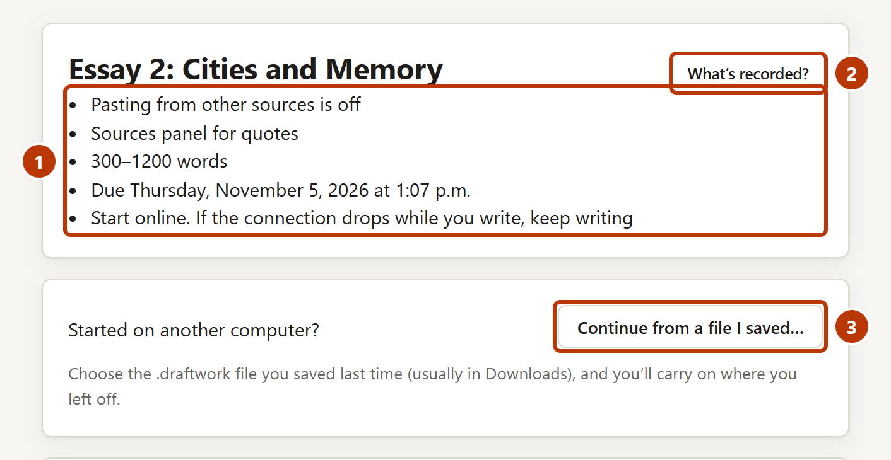
Figure 1. The top of the start page
Number | Item | What it is for
1 | Assignment rules | Shows the rules for this assignment. For example: if pasting is off, the word limits and the due date.
2 | What’s recorded? | Shows what Draftwork records and what it sends on the internet.
3 | Continue from a file I saved… | Use this button if you started this assignment on a different computer.

Start to write

Fill in the start form
- In the Name and student number box, type your name and your student number.
- Optional: in the Notes box, type notes for your instructor. For example: “I made an outline on paper first.”
- If you use dictation software, select I’m using dictation.
- Read the text in Before you start.
- Select the check box I understand what’s recorded.
- Click Start.

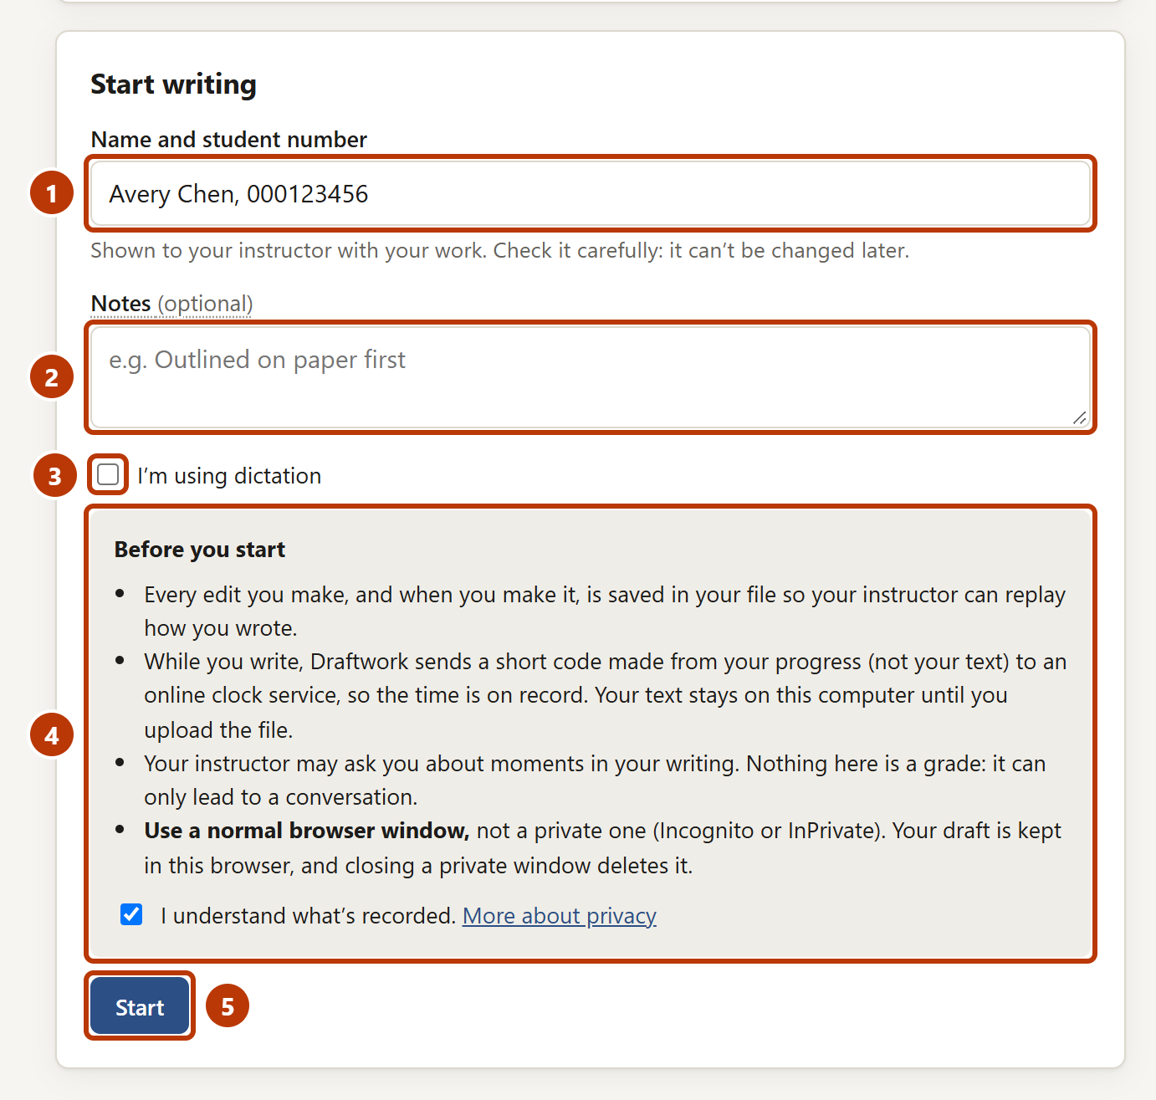
Figure 2. The start form
Number | Item | What it is for
1 | Name and student number | Your instructor sees your work with this name. You cannot change it after you start.
2 | Notes | Optional. Notes for your instructor about how you work.
3 | I’m using dictation | Select this if you use dictation software. Then your instructor knows that some text comes from dictation.
4 | Before you start | Tells you what Draftwork records, and to use a normal browser window. You must select the check box before you can start.
5 | Start | Starts the assignment.

Make sure that your name is correct
After you click Start, the window Is your name right? shows. It shows your name and student number.
- Read the name and the student number.
- If they are correct, click Yes, start writing.
- If they are not correct, click Go back and fix it. Correct the name. Then click Start again.

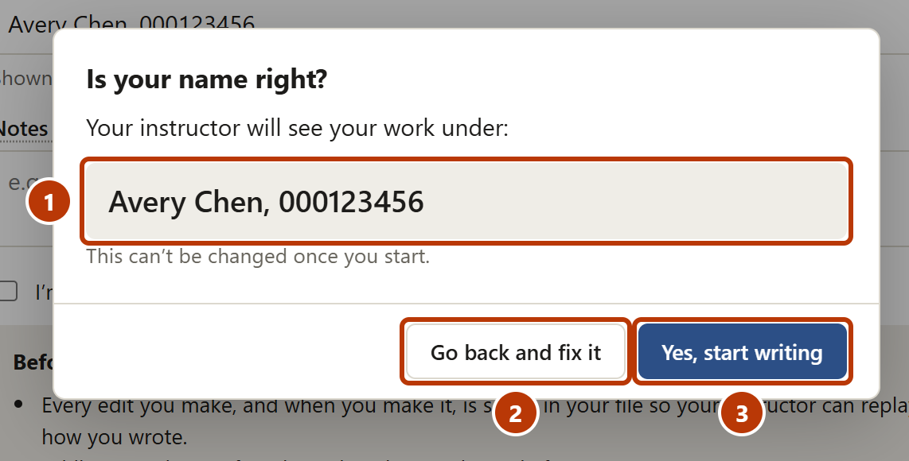
Figure 3. The window that shows your name
Number | Item | What it is for
1 | Your name | Your instructor sees your work with this name.
2 | Go back and fix it | Closes the window. Use it to correct your name.
3 | Yes, start writing | Starts the assignment with this name.

CAUTION: Make sure that your name and student number are correct. You cannot change them after you start.
NOTE: Draftwork must connect to the internet before you can start. If it cannot connect, a message shows. Make sure that your computer is online. Then try again.

The quick tour
When you start for the first time, a quick tour shows in the lower-right corner. The tour has three cards.
- Read the card.
- Click Next to see the next card.
- On the last card, click Got it. To close the tour at any time, click Skip.

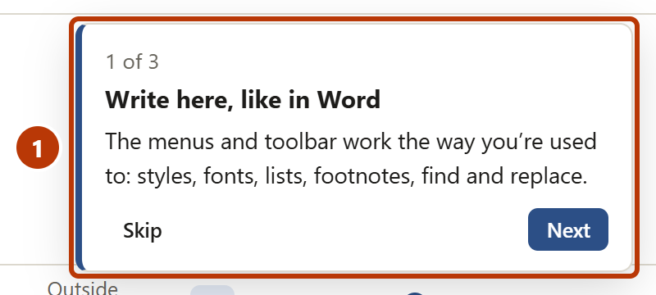
Figure 4. The first card of the quick tour
NOTE: To see the tour again, click Help, then click Show the quick tour.

The editor
The editor is the page where you write. It has three main areas.
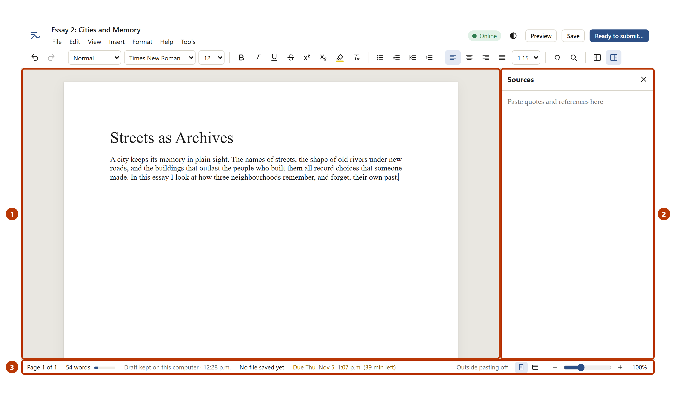
Figure 5. The three areas of the editor
Number | Item | What it is for
1 | The page | You write your assignment here.
2 | Sources panel | You can paste quotes and references here. Then you can copy them into your writing.
3 | Status bar | Shows the word count, the status of your draft and files, and the due date.

The top of the editor
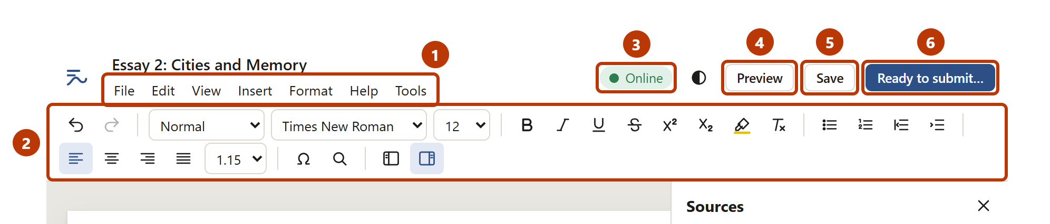
Figure 6. The menus, the toolbar and the buttons at the top of the editor
Number | Item | What it is for
1 | Menus | File, Edit, View, Insert, Format, Help and Tools.
2 | Toolbar | Styles, font, text size, bold, italic, lists, alignment, line spacing, special characters and find.
3 | Connection status | Shows Online or Offline · keep writing. Click it to read more.
4 | Preview | Shows a check of your work before you save and upload it.
5 | Save | Saves a backup file of your work. Use it while you write.
6 | Ready to submit… | Use it when you are finished. It saves the files for your course.

The status bar
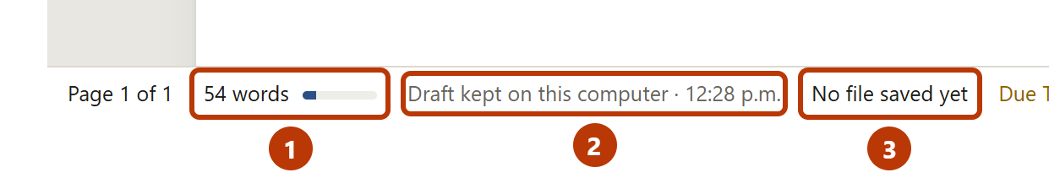
Figure 7. The left part of the status bar
Number | Item | What it is for
1 | Word count | The number of words. The bar shows your progress to the word limit. Click it to see more counts.
2 | Draft status | Draftwork keeps your draft on this computer. The time shows the last update.
3 | File status | Shows if you saved a file, and when. Click it to save a file.

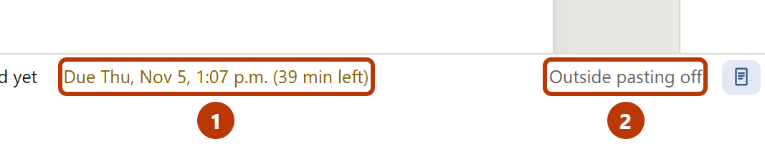
Figure 8. The right part of the status bar
Number | Item | What it is for
1 | Due date | The due date and the time that remains.
2 | Pasting rule | Shows Outside pasting off if you cannot paste text from other places.

Write and format your work
Draftwork operates like a typical word processor. You can use the menus, the toolbar and the usual keyboard shortcuts.
To do this | Use this
Make text bold, italic or underlined | The toolbar, or Ctrl+B, Ctrl+I, Ctrl+U
Make a title or a heading | The style list on the toolbar (Title, Heading 1, Normal)
Make a Works Cited page | Insert > Works Cited heading (a new page, a heading, and entries with a hanging indent)
Change the font or size of some text | Select the text. Then use the font list and the size list on the toolbar.
Change the font of all the text | Format > Default font…
Add a footnote | Insert > Footnote, or Ctrl+Alt+F
Add a header and page numbers | Format > Header and page numbers…
Find or replace text | Ctrl+F (find) or Ctrl+H (replace)
Undo or redo | Ctrl+Z (undo) or Ctrl+Y (redo)
See the word count | Click the word count in the status bar, or Tools > Word count…

NOTE: Draftwork records each change that you make and the time of the change. Your instructor can replay how you wrote your assignment. Write as you usually do.

Save a backup file while you write
Draftwork keeps your draft on this computer. A backup file keeps your work safe if the browsing data is cleared. Use a backup file to continue on a different computer.
- Click Save, or press Ctrl+S.
- Read the message. The .draftwork file is in your Downloads folder.

NOTE: Save does not make a Word document. It does not submit your work. When you are finished, click Ready to submit….

If the internet connection stops
If the internet connection stops, the connection status shows Offline · keep writing. Continue to write. Your work is safe on your computer. Draftwork records the time when the connection comes back.
If the connection stays off for more than 8 minutes, a message shows. Do these steps:
- Make sure that your computer is connected to the internet.
- If the problem continues, click Ready to submit… and upload your files as usual.
- Tell your instructor about the problem.

Use quotes from your sources

When pasting is off
Your instructor can turn off pasting from other places. Then the status bar shows Outside pasting off. You can still use quotes. Put them in the Sources panel first.
- Copy the quote from your source, for example a web page or a PDF.
- Click in the Sources panel.
- Paste the quote (Ctrl+V).
- Type the author, the title and the page after the quote.
- In the Sources panel, select the quote. Copy it (Ctrl+C).
- Click in your document where the quote goes. Paste it (Ctrl+V).

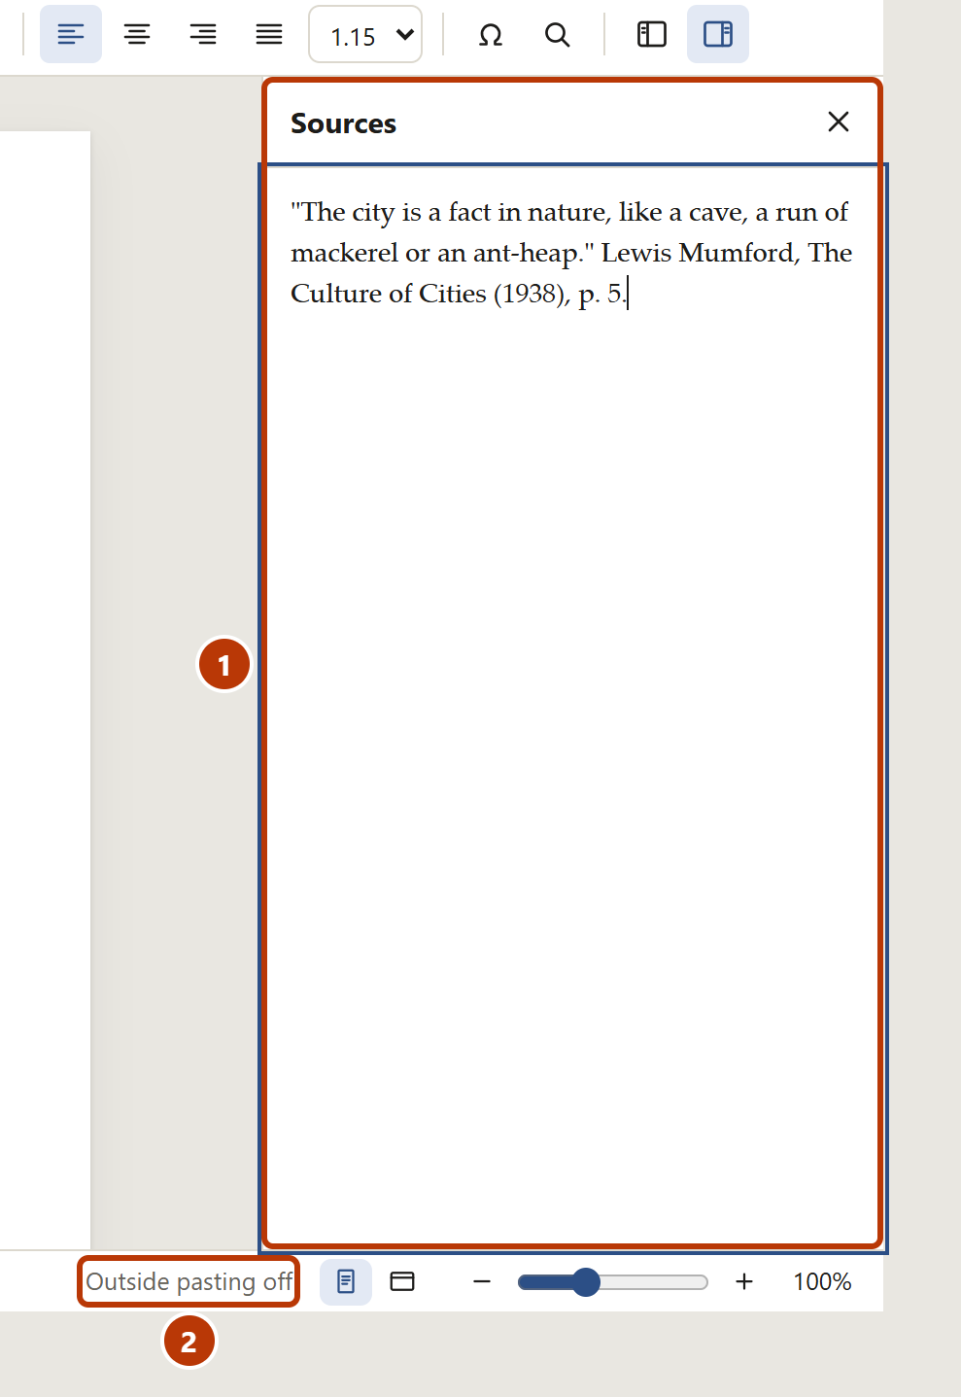
Figure 9. The Sources panel with a quote and its reference
Number | Item | What it is for
1 | Sources panel | Paste quotes and references here.
2 | Outside pasting off | Shows that you cannot paste text from other places directly into your document.

NOTE: You can always cut, copy and paste text inside your own document.
NOTE: If you do not see the Sources panel, click the panel button at the right end of the toolbar.

When pasting is on: “Where’s this from?”
If your instructor lets you paste, a small box shows after you paste text from another place. It asks where the text comes from.
- Type the author, the title, the page or the link in the box.
- Click Add.
- If you do not want to add the source now, click the ✕ button.

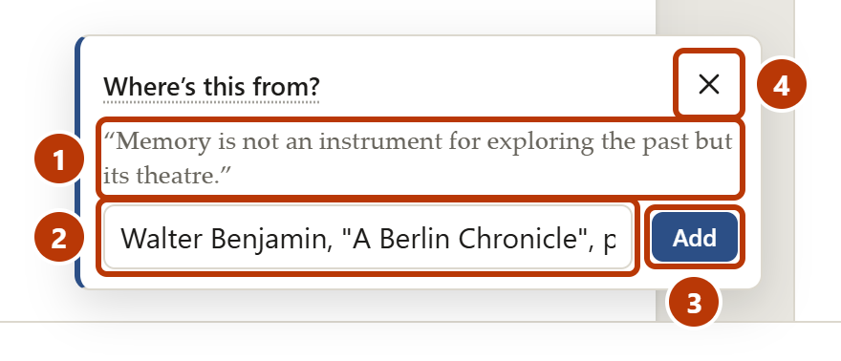
Figure 10. The box that asks where pasted text comes from
Number | Item | What it is for
1 | Pasted text | The start of the text that you pasted.
2 | Source box | Type the author, title, page or link.
3 | Add | Keeps the source with the pasted text. Your instructor sees it.
4 | ✕ | Closes the box without a source.

Add notes and answer the AI question
Use File > Notes… to tell your instructor how you worked.
- How you worked: for example, “I wrote the first draft on paper.”
- I’m using dictation: select this if you use dictation software.
- Did you use AI tools for this assignment?: this question shows only if your instructor asks it. Answer honestly. You must answer before you can click Ready to submit….
- Attach an outline or notes: Draftwork keeps only the name of the file, not the file.

Check your work with Preview
Use Preview before you save and upload your file.
- Click Preview.
- Read the summary at the top.
- Read each item in Before you save and upload. A tick shows that the item is correct. An exclamation mark shows an item to check.
- If there are flags, read each flag. Optional: type a note to your instructor in Your note about this.
- Click Back to writing.

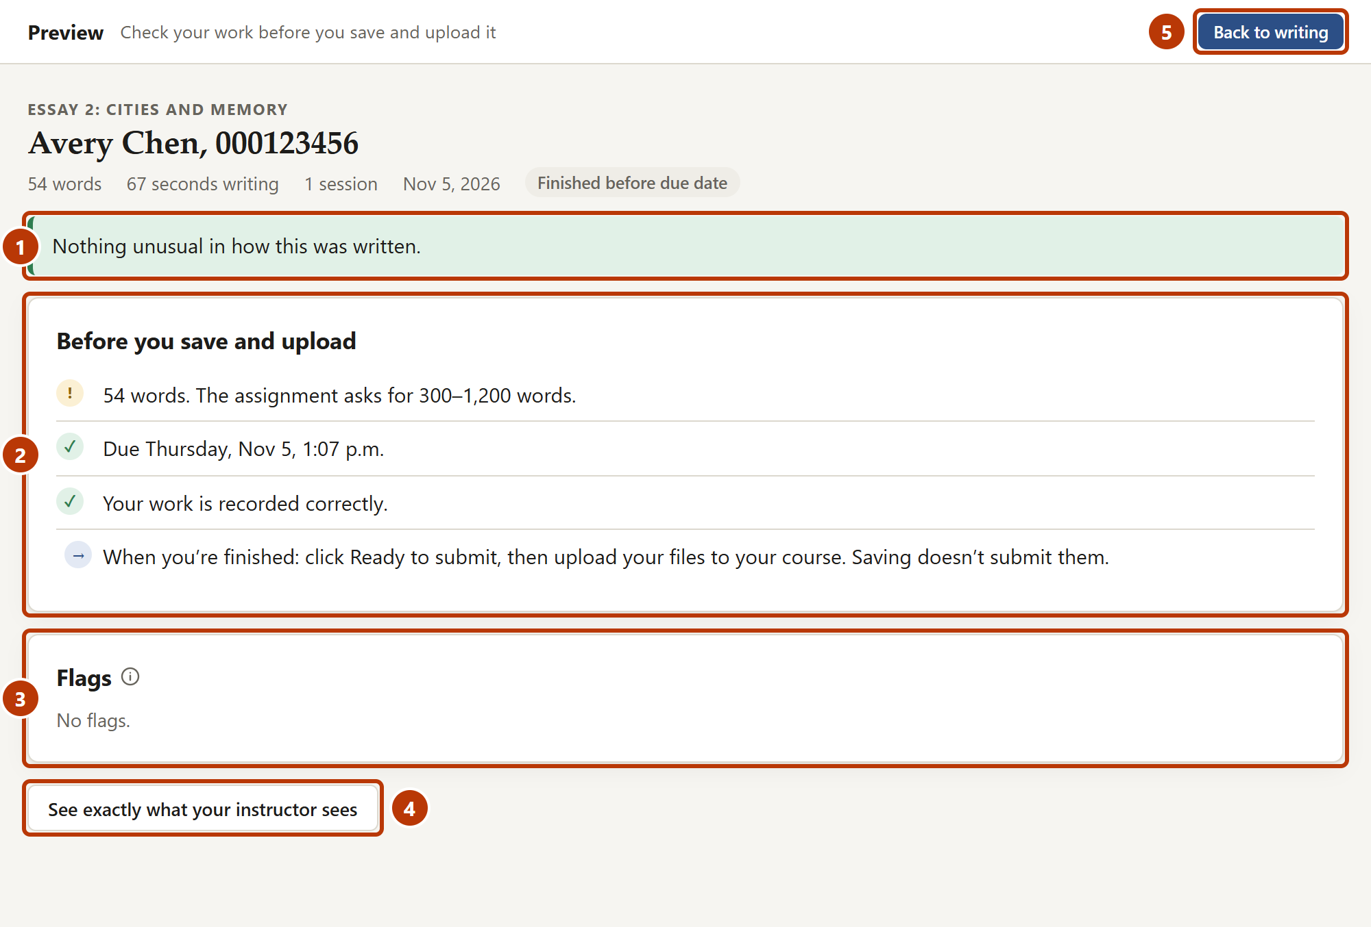
Figure 11. Preview
Number | Item | What it is for
1 | Summary | One sentence about your work.
2 | Before you save and upload | Checks of the word count, the AI question, the due date and the record of your work.
3 | Flags | Parts of your writing that your instructor can ask about. You can add a note to each flag.
4 | See exactly what your instructor sees | Shows the full page that your instructor sees.
5 | Back to writing | Closes Preview.

NOTE: A flag is not a grade. A flag shows a part of your writing that your instructor can ask you about.

Save your files, then upload them
CAUTION: When you save your files, you do not submit your assignment. Your assignment is submitted only when you upload your files. You must always upload the .draftwork file.

Save the files for your course
- When you are finished, click Ready to submit…. Draftwork saves the .draftwork file in your Downloads folder.
- Read the window Not submitted yet: save and upload your files.
- Click Save the Word document. The Word document goes to your Downloads folder.
- Click Copy receipt. Keep the receipt in a safe place, for example in an email to yourself.
- Click OK.

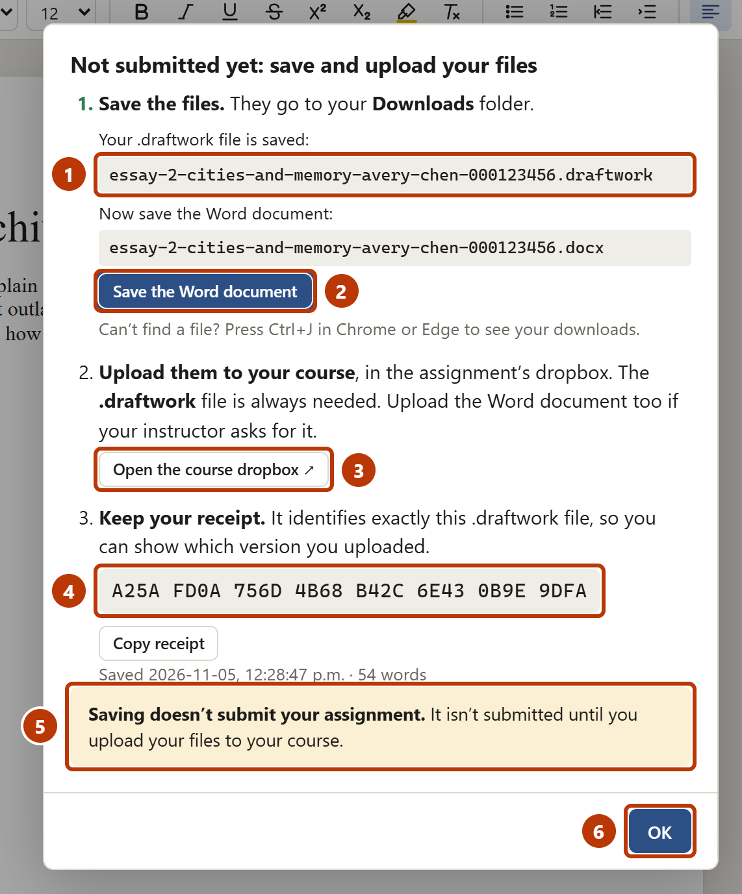
Figure 12. The window after you click Ready to submit
Number | Item | What it is for
1 | .draftwork file | The name of the file in your Downloads folder.
2 | Save the Word document | Saves a Word document of your work, with the same name, in your Downloads folder.
3 | Open the course dropbox | Opens the dropbox in your course site. This button shows only if your instructor added the link.
4 | Receipt | A code that identifies your .draftwork file. Your instructor sees the same code.
5 | Message | Tells you that you must upload your files to submit your assignment.
6 | OK | Closes the window.

Upload the files to your course
- Go to your course site. Or click Open the course dropbox.
- Open the dropbox for the assignment.
- Upload the .draftwork file from your Downloads folder.
- If your instructor tells you to upload the Word document, upload it too.
- Make sure that the course site shows that your upload is complete.

CAUTION: Your instructor tells you which files to upload. Read the instructions for the assignment. You must always upload the .draftwork file. A Word document alone does not show how you wrote your work.
NOTE: If you cannot find the file, press Ctrl+J in Chrome or Edge. This shows the list of downloads.
NOTE: If you write more after you upload, click Ready to submit… again. Then upload the new files. The new .draftwork file has all of your work from the start.
After you click Ready to submit…, the status bar shows the time and a reminder to upload your files.
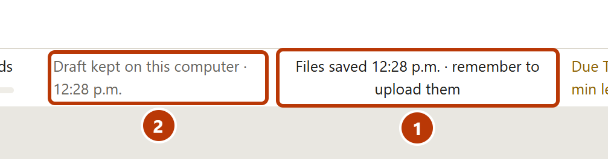
Figure 13. The status bar after you save your files
Number | Item | What it is for
1 | File status | Shows the time of the last save and reminds you to upload your files. If you write more, it tells you to click Ready to submit… again.
2 | Draft status | Draftwork continues to keep your draft on this computer.

Reminders before the due date
A reminder shows below the toolbar one day before the due date, one hour before the due date, and after the due date. The reminder tells you what to do next. Click Ready to submit… in the reminder to save your files. Click ✕ to close the reminder.
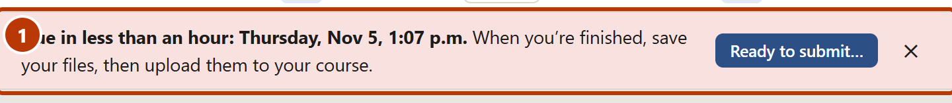
Figure 14. A due date reminder

Continue your work later

On the same computer
- Open the assignment link in the same browser.
- In Continue your draft, click Continue writing.

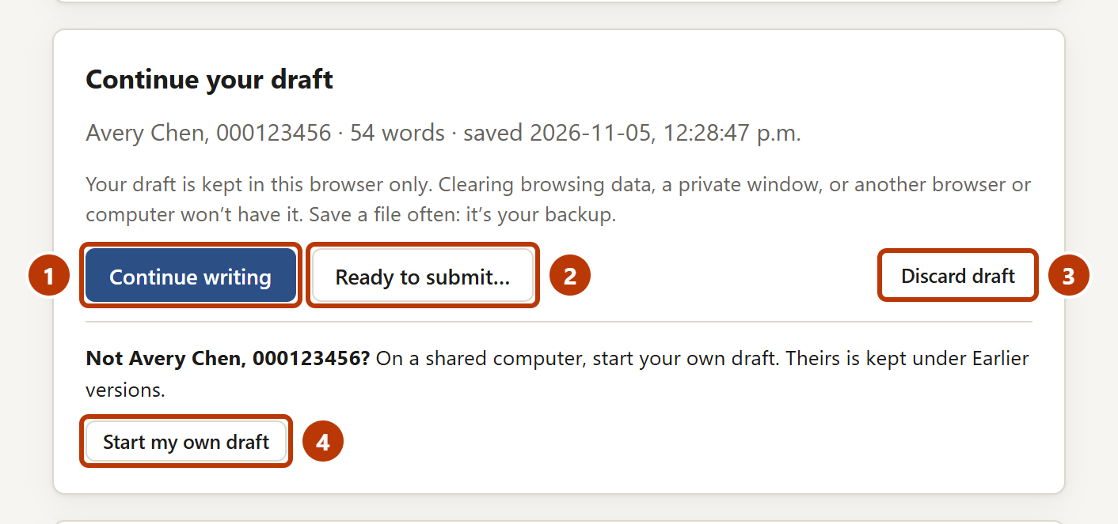
Figure 15. Continue your draft
Number | Item | What it is for
1 | Continue writing | Opens your draft.
2 | Ready to submit… | Saves the files for your course without opening the draft.
3 | Discard draft | Removes the draft from this computer.
4 | Start my own draft | Use this if the draft is not yours. The draft of the other person stays in Earlier versions.

CAUTION: Click Ready to submit… before you click Discard draft. You cannot get the draft back after you discard it.
CAUTION: If the name in Continue your draft is not your name, do not click Continue writing or Discard draft. Click Start my own draft.
NOTE: Your draft is kept only in the browser that you used. A private window, a different browser or a different computer does not have it. If you clear the browsing data, the draft is removed. Click Save frequently. The file is your backup.

On a shared computer
On a computer that other students use, for example in a library or a lab, the draft of a different student can show.
- Open the assignment link.
- If Continue your draft shows the name of a different person, click Start my own draft.
- Click OK. The start form shows.
- Fill in the start form for yourself.

Draftwork does not delete the draft of the other student. It is in Earlier versions on the start page, with that student’s name.
NOTE: On a shared computer, click Save before you leave. Then keep the file in your OneDrive. The next person can use the same browser.

On a different computer
On the first computer:
- Click Save.
- Keep the .draftwork file where you can get it on the second computer. For example: your OneDrive, a USB drive or an email to yourself.

On the second computer:
- Open the assignment link.
- Click Continue from a file I saved….
- Select the .draftwork file. Draftwork opens your work.

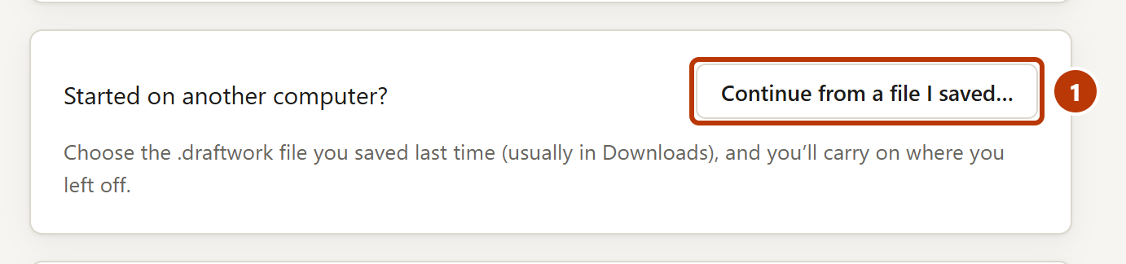
Figure 16. Continue from a file that you saved

If you have a problem
Problem | Possible cause | What to do
The message “This computer is offline” shows when you start. | The computer is not connected to the internet. | Connect to the internet. Then click Start again.
The message “Draftwork can’t reach the online clock service” shows. | The network blocks the service, or the service is not available. | Wait some minutes and try again. If the problem continues, tell your instructor.
The message “This assignment is already open in another tab or window” shows. | The assignment is open in a different tab. | Close the other tab. Then try again.
You cannot paste text into your document. | Your instructor turned off pasting from other places. | Paste quotes into the Sources panel. Then copy them from there.
The message “A browser extension or script tried to change your text” shows. | An extension, for example a grammar checker, tried to change your text. | Nothing changed in your text. Turn off the extension for Draftwork, or continue to write.
The connection status shows Offline · keep writing. | The internet connection stopped. | Continue to write. Make sure that the computer is online. If the problem continues, tell your instructor.
You cannot find your saved file. | The browser saved it to a different folder. | Press Ctrl+J in Chrome or Edge to see the list of downloads.
Your draft is not on the start page. | You used a different browser, a private window or a different computer, or the browsing data was cleared. | Use the same browser. Or click Continue from a file I saved…. Or open Earlier versions on the start page.
Continue your draft shows the name of a different person. | A different student used this assignment on this computer. | Click Start my own draft. The draft of the other student is not deleted.
You do not have a Word document. | You did not click Save the Word document, or you clicked Save. | Click Ready to submit…. In the window, click Save the Word document.
The course site does not accept your file. | The dropbox does not accept .draftwork files or .docx files. | Tell your instructor. The dropbox must accept the files that you must upload.
Draftwork tells you that it operates only on desktop and laptop computers. | You use a phone or a tablet. | Use a desktop computer or a laptop computer.

For more help, open Help > Help and troubleshooting in the editor. If the problem continues, click Save and contact your instructor.

Words used in this guide
Word | Meaning
Draft | Your work while you write. Draftwork keeps it in your browser on this computer.
.draftwork file | The file that you save and upload to your course. It contains your work and the record of how you wrote it.
Dropbox | The place in your course site where you upload an assignment.
Flag | A part of your writing that your instructor can ask about. A flag is not a grade.
Online clock service | An internet service that records the time of your progress. Draftwork sends it only a short code, not your text.
Preview | A check of your work before you save and upload it.
Receipt | A code that identifies your saved .draftwork file. Your instructor sees the same code.
Word document | A copy of your work as a .docx file. Your instructor can see it in the course site. It does not show how you wrote your work.
Sources panel | A panel at the right of the editor. You can paste quotes and references into it.
Upload | To send a file from your computer to your course site.

